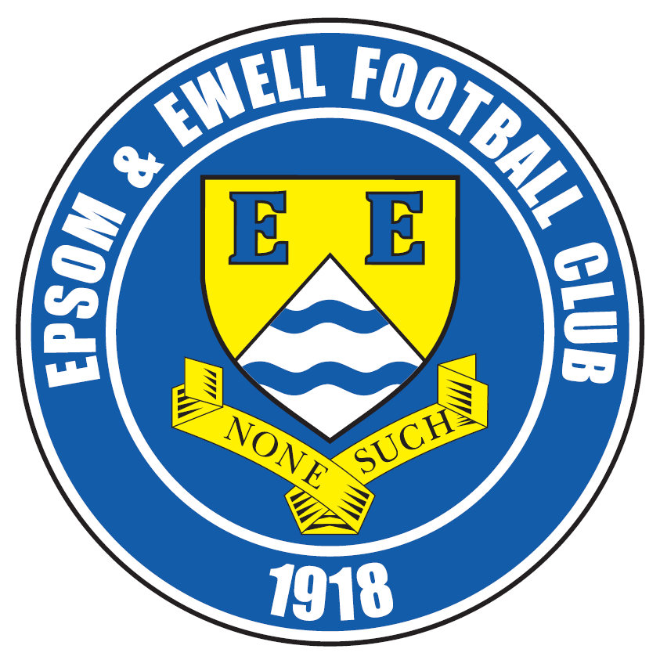 | Epsom & Ewell F.C.  18  v  Spelthorne Sports  Saturday, 16th January 2016 – 3.00 p.m.
Good afternoon! We welcome the players, supporters and officials of Spelthorne Sports Football Club, together with the match officials and our own regular supporters for this important League match.

We lost our very first meeting against our opponents on penalties in a Southern Combination Cup Semi-Final after a 0-0 draw during their stellar 2013-14 season, but since then have had a perfect record against them with three wins. Last season we ended their 18 month unbeaten home record with a fine 3-0 win and then edged an exciting return match in December when we had Alex McGregor sent off, lost a two goal lead twice, and then scored a late winner through Matt Ferdinando; his second of the match, to win 4-3. This season we won 6-2 in Middlesex on a day where we scored some stunning goals, but our opponents have changed substantially since that day and now hold a very healthy league position, when back in September there would have been whispers of relegation.

We met Ashford Town (Mx) here on Tuesday, and we produced a very flat performance, losing by three goals to nil. It was a disappointing way to go out of the League Cup but ultimately, it makes no difference to our League status and if there is anything riding on the final game of the season when Ashford revisit, then I am sure the score will be a lot closer.

Next Saturday we travel to Windsor for another tricky looking League match. Like Spelthorne they have been climbing the table in recent weeks so will present another tough challenge. Following that match we will be holding a Club Fund Raising evening in Epsom and further details follow later in the programme. Obviously a club like ours needs all the funds it can get and entry is only £10 so please come along either with a team or we can put you into a team.

We then make the rearranged journey to AFC Hayes on Tuesday 26th January after it was postponed due to the rain last Saturday, but the date of our next home match is harder to work out. We are due to host Hartley Wintney on Saturday 30th January, but if they defeat Western League Bradford Town in the F.A. Vase today, as I expect them to, then we will have a Saturday off. When we know, we’ll let you know!

We are definitely at home three days later as our match against Redhill has been arranged for Tuesday 2nd February. We produced a full colour 44 page programme for that match, so will be using it on that day to save on costs, although it is full of information and there will of course be an up to date insert included, so regular supporters will miss nothing.

Enjoy the game!

Rich

You can now follow us on Facebook www.facebook.com/epsomandewellfc or Twitter @EEFCOfficial

Cover Photos by Gemma Jarman

- Matt Farrell scores the opener against Spelthorne here last December
- Matt Ferdinando smashes the ball in for our third goal in that match


Cherry Red Records Combined Counties League
Premier Division Table 2015/16
inc Tuesday 12th January | P | W | D | L | F | A | Pts | GD | H | A
Hartley Wintney | 22 | 18 | 2 | 2 | 67 | 21 | 56 | +46 | 30/1 | 3-3
Ashford Town (Mx) | 23 | 18 | 1 | 4 | 61 | 30 | 55 | +31 | 30/4 | 3-2
Epsom & Ewell | 22 | 14 | 6 | 2 | 54 | 20 | 49 | +34 | X | X
Camberley Town | 20 | 14 | 3 | 3 | 40 | 17 | 45 | +23 | 16/4 | 20/2
Colliers Wood United | 26 | 12 | 2 | 12 | 53 | 43 | 38 | +10 | 3-1 | 3-0
Hanworth Villa | 22 | 12 | 2 | 8 | 41 | 34 | 38 | +7 | 5-0 | 23/4
Horley Town | 21 | 11 | 4 | 6 | 50 | 30 | 37 | +20 | 27/2 | 2-2
Windsor | 23 | 8 | 8 | 7 | 41 | 42 | 32 | -1 | 2-2 | 23/1
Spelthorne Sports | 22 | 9 | 5 | 8 | 40 | 43 | 32 | -3 | 16/1 | 6-2
Sutton Common Rovers | 24 | 9 | 3 | 12 | 44 | 47 | 30 | -3 | 3-1 | 2-1
Raynes Park Vale | 23 | 9 | 2 | 12 | 46 | 49 | 29 | -3 | 3-1 | 28/3
AFC Hayes | 24 | 8 | 4 | 12 | 36 | 44 | 28 | -8 | 1-1 | 26/1
Guildford City | 23 | 8 | 3 | 12 | 46 | 57 | 27 | -11 | 4-0 | 2/4
Knaphill | 19 | 8 | 2 | 9 | 36 | 32 | 26 | +4 | 12/3 | 1-1
Farnham Town | 21 | 7 | 4 | 10 | 35 | 35 | 25 | 0 | 1-0 | 6/2
Westfield | 17 | 6 | 6 | 5 | 23 | 26 | 24 | -3 | 26/3 | 0-0
Chessington & Hook | 23 | 7 | 2 | 14 | 40 | 55 | 23 | -15 | 1-0 | 19/3
Bedfont Sports | 21 | 5 | 7 | 9 | 29 | 32 | 22 | -3 | 13/2 | 2-2
Badshot Lea | 21 | 7 | 1 | 13 | 26 | 53 | 22 | -27 | 9/4 | 1-0
Chertsey Town | 22 | 5 | 5 | 12 | 22 | 36 | 20 | -14 | 0-1 | 5/3
Redhill | 18 | 3 | 3 | 12 | 23 | 43 | 12 | -20 | 2/2 | 1-0
Cove | 17 | 1 | 0 | 16 | 9 | 73 | 3 | -64 | 15/3 | 7-0

Lucky Day? – 16th January
Played 11 - W 5 D 0 L 6 - F 19 A 29 - PPG 1.36 - Average
Our Club record against today’s visitors
Played 4 - W 3 D 1 L 0 - F 13 A 5 - PPG 2.50 - Fantastic
Largest wins and losses against today’s visitors
12th September 2015 - (A) W 6-2 - League
24th April 2014 - (H) D 0-0 - Southern Combination Cup (lost 4-2 on penalties)
Their Last visit
Tuesday 16th December 2014 - W 4-3 - Combined Counties League

Club Manager - Glyn Mandeville
Good afternoon everyone and welcome to today’s game against Spelthorne Sports.

Our performance on Tuesday against Ashford Town was a disappointing one and we all know we can produce a better one than that, and will need to if we are to keep pace with the leaders.

We are still missing players through injury and hope to get them back fit soon.

I hope you enjoy this afternoon’s game and have a safe trip home.

Cheers for all your support.


Manders

Club Captain - Sam Currie
Good afternoon and welcome to High Road for today’s league game against Spelthorne.

At this part of the season we know that games come thick and fast and we are glad of this to enable us to put the disappointment of Tuesday’s defeat in yet another cup tie behind us.

I have full belief the boys can get back on track after this and maintain our impressive league form of 2015.

With the full understanding that this is a difficult league with some good teams in, we are aware that we need to be on song every week and playing to our full ability at all times - if we can do this we certainly have one of the strongest squads in the league. However, games like Tuesday cannot happen and we are all fully aware of this.

Having said all this Spelthorne have a new management team in place since our away fixture and therefore possibly a slightly different squad and so the away fixture where we comfortably won earlier in the season must be ignored.

We hope you are in for a good game today – and hopefully one the Salts can gain maximum points from.

We wish the Spelthorne team and supporters a safe journey home following the game today and thank ours for their continued support.

Sam

Latest Results and Fixtures
Combined Counties League Cup – Tuesday 12th January
Camberley Town | 5-1 | Spelthorne Sports
Cobham | p-p | Frimley Green
Epsom & Ewell | 0-3 | Ashford Town (Mx)
Surrey Senior Cup – Tuesday 12th January
Whyteleafe | 6-0 | Farnham Town
Combined Counties League – Tuesday 12th January
Horley Town | 0-1 | Hartley Wintney
F.A. Vase Fourth Round – Saturday 16th January
Bowers & Pitsea | V | Sutton Common Rovers
Hartley Wintney | V | Bradford Town
Kidlington | V | Knaphill
Combined Counties League Cup – Saturday 16th January
Cobham | V | Frimley Green
Combined Counties League – Saturday 16th January
Badshot Lea | V | Windsor
Chertsey Town | V | Chessington & Hook United
Colliers Wood United | V | Westfield
Cove | V | Farnham Town
Epsom & Ewell | V | Spelthorne Sports
Guildford City | V | Horley Town
Hanworth Villa | V | AFC Hayes
Raynes Park Vale | V | Redhill
Combined Counties League – Tuesday 19th January
Camberley Town | V | Redhill
Chessington & Hook United | V | Sutton Common Rovers
Farnham Town | V | Knaphill
Combined Counties League – Wednesday 20th January
Colliers Wood United | V | Bedfont Sports
Guildford City | V | Hartley Wintney
Combined Counties League – Saturday 23rd January
Ashford Town (Mx) | V | Chessington & Hook United
Bedfont Sports | V | Westfield
Colliers Wood United | V | Camberley Town
Farnham Town | V | Spelthorne Sports
Hanworth Villa | V | Sutton Common Rovers
Latest Results and Fixtures
Combined Counties League – Saturday 23rd January
Hartley Wintney | V | AFC Hayes
Horley Town | V | Cove
Knaphill | V | Chertsey Town
Redhill | V | Badshot Lea
Windsor | V | Epsom & Ewell
Combined Counties League – Tuesday 26th January
AFC Hayes | V | Epsom & Ewell
Bedfont Sports | V | Windsor
Farnham Town | V | Westfield
Horley Town | V | Chertsey Town
Raynes Park Vale | V | Camberley Town
Redhill | V | Guildford City
Spelthorne Sports | V | Knaphill
F.A. Vase – Fifth Round – Saturday 30th January
Camberley Town | V | Newton Aycliffe / Marske United
Combined Counties League – Saturday 30th January
Some matches below could be postponed if the clubs concerned remain in the F.A. Vase
AFC Hayes | V | Badshot Lea
Ashford Town (Mx) | V | Colliers Wood United
Chertsey Town | V | Redhill
Chessington & Hook United | V | Farnham Town
Cove | V | Raynes Park Vale
Epsom & Ewell | prov | Hartley Wintney
Knaphill | prov | Horley Town
Spelthorne Sports | V | Windsor
Sutton Common Rovers | prov | Bedfont Sports
Westfield | V | Guildford City
Combined Counties League Cup – Tuesday 2nd February
Hartley Wintney | V | Chessington & Hook United
Combined Counties League – Tuesday 2nd February
Cove | V | Camberley Town
Epsom & Ewell | V | Redhill
Horley Town | V | Westfield
Knaphill | V | Hanworth Villa
Raynes Park Vale | V | Windsor

First Eleven Appearances - (max 27 – including Ashford Town – 12/01/16)
Name | Debut | 2014/15 |  |  |  | Career Totals
Name | Debut | App | Sub | Total | Goals | App | Sub | Total | Goals
AJAYI Tayo | 22/08/2015 | 0 | 2 | 2 | 0 | 0 | 2 | 2 | 0
COOPER-SMITH Daryl | 03/01/2015 | 15 | 4 | 19 | 8 | 24 | 7 | 31 | 14
CURRIE Sam | 04/08/2012 | 16 | 1 | 17 | 1 | 124 | 10 | 134 | 3
DAVISON Conor* | 22/08/2015 | 1 | 2 | 3 | 0 | 1 | 2 | 3 | 0
DEAN Dan | 02/08/2014 | 18 | 2 | 20 | 0 | 54 | 3 | 57 | 0
DOWNS Carl | 17/09/2011 | 4 | 1 | 5 | 0 | 98 | 14 | 112 | 2
EACOTT Michael | 02/08/2014 | 24 | 0 | 24 | 0 | 70 | 0 | 70 | 0
FARRELL Matt | 02/08/2014 | 26 | 0 | 26 | 5 | 67 | 3 | 70 | 12
FERDINANDO Matt | 20/09/2014 | 17 | 0 | 17 | 5 | 44 | 4 | 48 | 11
GRIFFIN Reisse | 08/08/2015 | 12 | 4 | 16 | 1 | 12 | 4 | 16 | 1
HASTINGS Craig | 08/08/2015 | 20 | 3 | 23 | 0 | 20 | 3 | 23 | 0
HATFIELD Jamie | 11/11/2006 | 1 | 0 | 1 | 0 | 249 | 13 | 262 | 6
HENDRY Rob | 08/08/2015 | 23 | 3 | 26 | 9 | 23 | 3 | 26 | 9
HOUGH Kyle | 14/08/2007 | 21 | 2 | 23 | 17 | 317 | 17 | 334 | 188
JONES Adrian | 06/08/2011 | 2 | 0 | 2 | 0 | 22 | 0 | 22 | 0
KURDZIEL Jakub | 29/08/2015 | 1 | 0 | 1 | 0 | 1 | 0 | 1 | 0
MARVELL Dale* | 15/01/2000 | 8 | 4 | 12 | 1 | 269 | 49 | 318 | 86
McGREGOR Alex | 08/08/2009 | 7 | 3 | 10 | 2 | 179 | 59 | 238 | 29
MCKAY Alex | 20/12/2008 | 18 | 1 | 19 | 0 | 103 | 27 | 130 | 8
NEALE Thomas | 13/10/2015 | 7 | 8 | 15 | 4 | 7 | 8 | 15 | 4
NEILL David* | 03/10/2015 | 1 | 1 | 2 | 0 | 1 | 1 | 2 | 0
NORTH Rhys | 16/08/2015 | 8 | 7 | 15 | 0 | 8 | 7 | 15 | 0
OLIVER Beckett | 29/08/2015 | 5 | 11 | 16 | 0 | 5 | 11 | 16 | 0
PANAYIOTOU Savvas | 03/01/2015 | 3 | 2 | 5 | 0 | 19 | 5 | 24 | 3
ROWE Steve | 27/08/2011 | 0 | 1 | 1 | 0 | 24 | 3 | 27 | 0
SMITH Matt | 08/08/2009 | 0 | 0 | 0 | 0 | 91 | 43 | 134 | 10
TANTON Matt | 02/08/2014 | 22 | 0 | 22 | 0 | 40 | 4 | 44 | 1
TAYLOR James | 26/08/2013 | 17 | 2 | 19 | 2 | 73 | 10 | 83 | 5
Own Goal |  |  |  |  |  |  |  |  | 1
* Player has left the club

EL Records Premier Challenge Cup
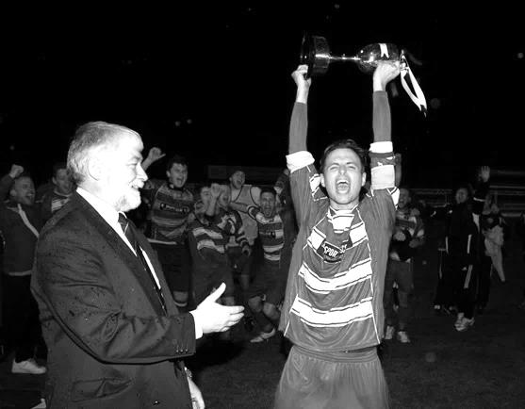
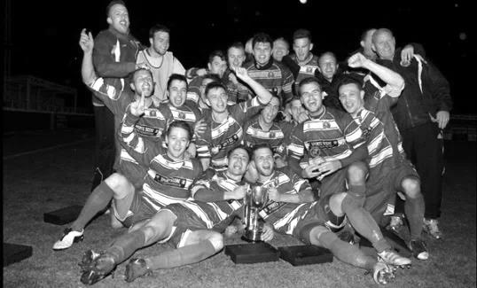
Second Round
Dorking Wanderers | 2-1 | South Park Reserves
Westfield | 1-0 | CB Hounslow United
Bedfont & Feltham | 1-5 | Colliers Wood United
Dorking | 0-3 | Knaphill
Badshot Lea | 2-4 | Spelthorne Sports
Hanworth Villa | 1-2+ | Chertsey Town
Ashford Town (Mx) | 2-1 | Epsom Athletic
Hartley Wintney | 4-2 | Horley Town
Banstead Athletic | 1-1+ | Epsom & Ewell
Epsom & Ewell won 7-6 on penalties
Sheerwater | 3-3+ | Frimley Green
Frimley Green won 8-7 on penalties
Farnham Town | 3-2 | Abbey Rangers
Camberley Town | 4-2 | Eversley & California
AFC Hayes | 0-1 | Banstead Athletic
Redhill | 3-0 | Sutton Common Rovers
Worcester Park | 1-5 | Chessington & Hook United
Cove | 1-6 | Cobham
Third Round
Camberley Town | 5-1 | Spelthorne Sports
Cobham | 16/1 | Frimley Green
Redhill | 9/2 | Farnham Town
Raynes Park Vale | 16/2 | Westfield
Epsom & Ewell | 0-3 | Ashford Town (Mx)
Colliers Wood United | 6-0 | Dorking Wanderers Reserves
Knaphill | 16/2 | Chertsey Town
Hartley Wintney | 2/2 | Chessington & Hook United
Quarter - Finals
Cobham / Frimley Green | V | Raynes Park Vale / Westfield
Knaphill / Chertsey Town | V | Redhill / Farnham Town
Camberley Town | 1/3 | Colliers Wood United
Hartley Wintney / Chessington & Hook | V | Ashford Town (Mx)

From behind the goal
Epsom & Ewell 0-3 Ashford Town (Mx)
Combined Counties League Cup – Third Round – Tuesday 12th January 2016

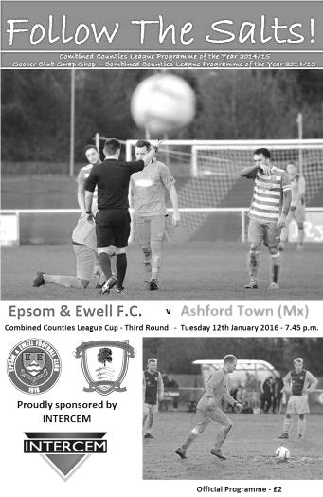
Salts depart League Cup with a whimper

After a two week break we came up against a very good Ashford Town side and were in the end comfortably defeated in this League Cup Third Round tie.

There were very few positives to take from this match in all honesty as we were caught cold by an early goal at the start of both halves, then conceded once more as we pushed to get back into the game. The visitors were well deserving of their victory and held the edge in every department, most notably up front where Dan Fleming scored all three of their goals, all of which were scored from inside the six yard box.

Upon looking at the team sheet it was disappointing to note the continued absence of Matt Ferdinando, Sam Currie and James Taylor, as their injuries have proven much more difficult to shake off than was at first thought. Taylor was on the bench as was Carl Downs, but neither came on. Throw in the suspended Matt Tanton and this left us without our first choice full backs for this important match. In place of Currie and Tanton were the versatile Alex McKay at right back, while our recently signed former Captain Jamie Hatfield would fill the left back slot, although by his own admission, he hadn't played for a while and it will take him a few weeks to get back to match fitness, lasting just under the hour before having to come off.

Under the circumstances it might have been better to face a team lower down the table but the League Cup had paired us with the league leaders and we were just going to have to make the best of it. However, we just didn't get going, and a break down our right flank ended up with a heavy touch from Matt Farrell who needlessly conceded a corner. From the short corner, one of many they exploited throughout the match, a low shot was sent in and it appeared that Michael Eacott was unsighted at first. Bearing this in mind, he did really well to get down and block the initial strike, but we didn't follow the ball in and there was Fleming, stood next to a visiting team mate who had the simple job of tapping the loose ball into the net while we looked forlornly at the Assistant Referee for an offside that wasn't there. We had only been playing for 100 seconds.

An early goal is always a concern, but you could argue that we were going to have to score to win the game anyway, so nothing had really changed, and we were nearly on level terms within a minute after a corner of our own was headed at goal by Craig Hastings, but Joe Green headed the ball off the line and from the half clearance Reisse Griffin sent a stinging shot a couple of feet over the bar from fully thirty yards.

Both sides looked dangerous going forward, with Savvas 'Agi' Panayiotou causing trouble with some early attacking runs, and the midfield battles were both combative and

competitive, but very little in the way of real interest really happened at either end with exception of a booking for either side. We then missed a chance to equalise in the 38th minute when from a free kick on the edge of the box was drilled in low by Rob Hendry and Griffin got a toe to it but poked the ball just wide of the near post with visiting keeper Tobin heading towards the far post.

As the half neared its end Griffin hit another powerful volley just over the bar from the angle of the penalty area after outmuscling a defender and Tom Neale saw his shot deflected for a corner after Farrell had originally broken through and challenged for a loose ball with Tobin. We did have a scare of our own in injury time when McKay sliced a ball across field and Fleming was onto it, just getting a toe to the ball ahead of Eacott, but his touch was heavy and the ball ran out for a goal kick before he could reach it.

If we thought we had got away with it after that narrow escape, those thoughts were crudely shattered within three minutes of the second half when we lost the ball in midfield after having a shout for a handball turned down and a ball over the top of our defence to their right winger enabled him to get to the line and pull the ball back across goal where Fleming was totally unmarked again and knocked the ball into the net in similar fashion to his first goal.

A similar move just moments later required a good save from Eacott and soon after Hastings was required to head clear a goalbound effort. We were struggling at this point but weathered the storm and in the 57th minute nearly got back into it when a Farrell cross from the left wing was caught and then dropped by Tobin under a bit of pressure from Neale. The ball fell to the ground and rolled in and just for a moment it looked like the goal had been given as there was no signal from either official before the referee just decided to award a free kick without blowing his whistle at any point. It was debateable whether there really was a foul by Neale, but those sort of incidents are usually ruled in favour of the keeper and so it went.

We were starting to exert a bit of pressure and when Neale and then Hough were fouled in the same move, the latter challenge earned a yellow card for the visiting skipper Canderton, but the move had been broken up which was the original intention and we were unable to make the set piece count. Neale picked up his own yellow card just after this before one of our substitutes Alex McGregor sent a strike towards the far corner but it was headed away by a defender and moments later the game was all over as another right wing cross was headed in by the unmarked Fleming at close range in the 77th minute with Eacott having no chance.

And they could have had two more as the visitors broke through again, but the first time the attacker was off balance the shot was sliced well wide and on the second, Eacott stood up well and made the save. Ultimately on a very cold night we produced a very cold performance and whilst it could be argued that we had been out of action for a week or two, we need to ensure that we improve for Saturday when Spelthorne Sports visit us for a League match or we will find our title chances slipping away as quickly as our cup chances did this evening.

Team: Michael Eacott, Alex McKay, Jamie Hatfield, Craig Hastings, Dan Dean, Savvas 'Agi' Panayiotou, Rob Hendry, Matt Farrell (c), Kyle Hough, Tom Neale, Reisse Griffin

Subs: Rhys North for Hatfield (53), Alex McGregor for Hendry (67) Beckett Oliver for Griffin (82)

Club Records - 16th January
Date | Day | Competition |  | Opponents |  | Scorers
16/01/32 | Sat | Amateur Cup 2 | A | Wycombe Wanderers | 2-7 | T.Dunne, R.Marlow
16/01/37 | Sat | London League | H | Eton Manor | 3-5 | H.Pullen, E.George, J.Jones (pen)
16/01/54 | Sat | Corinthian League | A | Slough Town | 1-5 | B.Wiles
16/01/60 | Sat | Corinthian League | H | Dagenham | 4-2 | S.Law, F.Vernon, V.Jones, N.Dearlove
16/01/65 | Sat | Athenian League 1 | H | Wembley | 2-1 | B.Mackay, o.g.
16/01/71 | Sat | Athenian League 2 | H | Eastbourne | 1-2 | K.Ward
16/01/79 | Tue | Isthmian League 1 | A | Bromley | 0-3
16/01/82 | Sat | F.A. Trophy 3q  2nd replay | A | Gravesend & Northfleet | 1-0 | T.Tuite
16/01/88 | Sat | Isthmian League 2s | A | Harefield United | 2-1 | M.Elliott, S.Flack
16/01/93 | Sat | Isthmian League 3 | A | Camberley Town | 1-0 | R.Purvis
16/01/10 | Sat | F.A. Vase 4 | A | Long Buckby | 2-3 | K.Hough (pen), R.Burns
Historical Decades
Date | Day | Competition |  | Opponents |  | Scorers
90 years ago – Epsom Town F.C.
23/01/26 | Sat | Surrey Senior Cup 1 | H | Summerstown | 2-4 | R.Marlow (2)
80 years ago – Epsom F.C.
18/01/36 | Sat | London League | H | Dagenham Town | 8-3 | B.Harris (4), H.Pullen (3), B.Neal
70 years ago – Epsom F.C.
19/01/46 | Sat | Friendly | H | R.E.M.E. Putney | 9-2 | G.Brogdale (5), F.Adey (2), S.Tingey, o.g.
60 years ago – Epsom F.C.
21/01/56 | Sat | Corinthian League | H | Eastbourne | 4-0 | B.Jenkins, J.Berry, J.Sorensen, D.Hermitage
50 years ago – Epsom & Ewell F.C.
22/01/66 | Sat | Athenian League 2 | H | Cheshunt | 0-3
40 years ago – Epsom & Ewell F.C.
17/01/76 | Sat | Athenian League 2 | H | Molesey | 2-1 | A.Reid, J.Eales
30 years ago – Epsom & Ewell F.C.
18/01/86 | Sat | Isthmian League Premier Division | H | Walthamstow Avenue | 1-2 | R.Kidd
20 years ago – Epsom & Ewell F.C.
15/01/96 | Mon | Surrey Senior Cup 1 | A | Woking | 0-6
10 years ago – Epsom & Ewell F.C.
17/01/06 | Tue | Isthmian League 2 | H | Chertsey Town | 4-2 | C.Heuston, L.Purvis, C.Read, D.Marvell

History Corner – 16th January
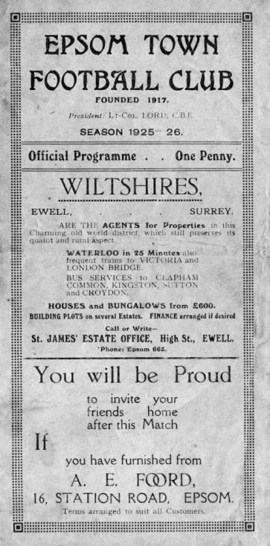
90 years ago this week we departed the Surrey Senior Cup at home to Athenian League Summerstown by four goals to two (see programme right). Reg Marlow scored twice but they just had too much for us. However, within eighteen months they had folded and disappeared without trace. The Earlsfield Road grand stand survived for a while longer though, being transported to Lower Mead, Wealdstone where it witnessed many years of service before the ground was demolished in the early nineties.

84 years ago today we travelled to Loakes Park for our one and only visit to the last 32 of the Amateur Cup. Having just won 4-2 at Portman Road against Ipswich Town in front of 5,000 people in the previous round, we feared no one, but our Captain George Mackesy had been sent off in that match and was suspended for this tie which was crucial. Despite taking an early lead in front of 7,000 spectators, we were no match for the Isthmian League giants who were also the Cup holders and we trailed 5-1 at the break, eventually losing 7-2.

80 years ago this week we destroyed Dagenham Town by eight goals to three at West Street. This club had no connection to the current club which were founded directly after the Second World War, but they were their pre-war equivalent, playing at Glebe Road, Dagenham. Our nippy winger B.Harris had his best day for the club, scoring four times while Jackie Pullen scored three.

70 years ago today we had a friendly match at West Street against Crawley. They were a tiny Mid-Sussex League team at this stage and only started to move up into the Sussex League in 1951 and then the Metropolitan League before reaching the Southern League in 1963. A Gordon Brogdale hat trick set us on our way with this 5-3 victory, even though it was only 1-1 at half time. I doubt we’d have the same success against them these days!

34 years ago today we reached the last 64 of the F.A. Trophy. We had defeated Thanet United (now Margate) and Tonbridge before being paired with Alliance Premier League Gravesend & Northfleet. After one postponement in December, we drew 1-1 at home before the fun really started and the replay at Stonebridge Road was called off a few times. When we finally played we trailed 3-2 with seconds remaining, only for a home defender to score a thirty yard own goal and earn us a second replay, which was also played there, but Tommy Tuite scored early on and despite his penalty being saved towards the end it didn’t cost us. Next up, was a trip to Cheltenham Town who we also defeated before hosting the mighty Altrincham in the last 32!

22 years ago today the team coach nearly got lost on the way to the Harefield United ground as it couldn’t find its way due to a dense carpet of fog. However, the game still went ahead and we won 2-1, although very few were able to see the late winner from Steve Flack. Because of the fog I was not standing behind our goal, which I instantly regretted, when we all heard a loud cheer!

6 years ago today we had an appearance in the last 32 of the F.A. Vase for the first time since 1989 and travelled to Northampton to face Long Buckby, a United Counties League team. We led early through a soft penalty but they equalised soon after when Paul Borg appeared to be fouled but it wasn’t given. By half time we trailed 3-2 though and although we got a late goal back, we were unable to force an equaliser.

Spelthorne Sports F.C. – History

Spelthorne Sports Club was founded in 1922 having purchased around 11 acres of land and has been providing sports for the local community ever since. We currently have 2 full sized football pitches and field 3 adult football teams and 2 Sunday teams along with a Youth Section covering Little Kickers through to the Mid-week Flood Lit Under 18’s, a total of 21 youth teams competing every Sunday in the Surrey Youth and Surrey Primary Leagues. The Youth Section was awarded the FA Charter Standard in March 2010 and the Annual Youth Tournament draws in many local teams since its inauguration in 2010.

In season 1998-99, Richard Ford and Micky Fisher took control of their 1st full season and saw them rise up the table. Both players were long serving Spelly players and had now moved into the management side. The team were led by Paul Fernadez with Paul Wilson in goal and Ian & Nick Croxford playing their 1st seasons with Spelly. We finished the season in 3rd spot and reached the final of the Russell Grant cup, where Sports did their usual thing of blowing it and lost to Northolt Saints 2-0 in the final at Uxbridge after they had beaten and drawn with them earlier in the season. (P18 W10 D5 L3 F35 A18 P35)

2001 was the first season of the new management team of Paul Martyn Jones (Trigger) and Ian Croxford. The team had the two scoring machines of James (OGGY) Hogg and Nick Croxford playing up front and with eventual player of the year Wes Coles in goal this was the most successful season for many a year. The team went from October through to April without losing a league game taking the league title in front of Willesden Constantine by 5 points, they were on the road to a league and cup double but were beat in the semi-finals by Willesden with future professional footballer Enoch Showammi smashing home a 25 yard free kick.

In 2007, after many great years playing in the Middlesex League it was decided that a move to the Surrey League was required. The main driving force for this was that the league had expanded so that games were all across London and for an Amateur side, an away trip to Bethnal Green was an all-day event!

The move to the Surrey Intermediate League Western Division was a change that was needed with pleasant drives through the country playing village teams rather than long hauls across London.

With the management now in the hands of Steve Flatman, a long time player and member of the club, the team saw a steady growth and this has to be credited to Steve. The first season saw Sports finish 7th (P26 W10 D10 L6 F50 A39 P40) with Horsley running away with the league. The next season saw some old faces come back into the team to support the young bucks with Oggy, Mike Jenkins and Ian Croxford coming back to support the team. The team finished second behind Ripley with Rob Smith finishing top league scorer with 21 and Lee Staples not far behind on 19.

The season had its climax when Sports played their first final in many a year against Abbey Rangers at a very dusty Cobham FC and with the team leading 1-0 at half time through a Jake

Flatman goal they somehow grabbed defeat from the jaws of victory losing 2-1 with a spectacular 20 yard own goal from Aaron Stewart.

In 2009, Spelthorne Sports again moved leagues for the second time in three seasons as we progressed up through the FA pyramid system, this time to the Surrey Elite league. The season started well but it was discovered that a (nameless) player had played with a ban from his now disbanded Sunday team. This resulted with Spelly being deducted all points that had been awarded while he was playing that season, 9 in total. Spelly finished the season 5th (P28 W17 D1 L10 F70 A52 P43) if we had not lost the points we could possibly have finished third or even higher as the disappointment of losing these points was a bitter pill to swallow.

In the 2010-11 season Spelthorne Sports Football Club 1st Eleven Completed a league and cup double victory by winning the Surrey Elite Intermediate League and the Surrey Intermediate Challenge Cup. Their league success means they won promotion to the Combined Counties League. Steve Flatman continues to be involved with the football section and is always on call!

In 2013–14, the Spelly won the Middlesex FA Intermediate Cup, beating Middlesex County Premier side Cricklewood Wanderers 3–0 in the Final. On 16 April 2014, Spelthorne Sports were crowned Combined Counties Division One Champions with a 2–1 win away to Epsom Athletic. They lifted the trophy three days later following an emphatic 7–0 win at home to local rivals Staines Lammas. We also won the RPM Records Division One Challenge Cup against Staines Lammas at Windsor FC on 5 May 2014. A single second half Lee Staples goal was enough to make sure we lifted the trophy, winning the league and cup treble in the process.

The team went on a phenomenal 46 game unbeaten run in all competitions that season, beating teams in cup competitions from higher divisions such as Frimley Green, Staines Town (on penalties), Walton Casuals, Wembley, and Epsom & Ewell (on penalties). That unbeaten run finally came to an end on 7 May 2014 when they played Combined Counties Premier Division side Hanworth Villa in the Southern Combination Cup Final, losing 1–0. The game was played at home and marked the club's first ever game under the newly installed floodlights. The lads then suffered their second defeat of the season to the same opposition when the sides met again three days later in the Cherry Red Records Premier Challenge Cup Final, again losing 1–0.

It was an extremely successful for the club. Winning two cup finals, and finishing runners-up in another two cup finals. However the biggest achievement by far was winning the League without losing a single game in the process. Winning 22, drawing 8, losing 0, scoring 92, and conceding 23.

Season 2014-2015 saw us in action in the Combined Counties Premier Division where we finished in a very respectful 6th position. We also experienced our first entry into the FA Vase. The promotion led to vast ground improvements yet again and this work continues to be done.

This season sees a change of management back under the control of Steve Flatman with support from Paul Burgess and Mark Harper. We are looking forward to seeing the continued development of football at ‘The Spelly’.

Centre page for results

Centre page for results



Surrey Senior Cup
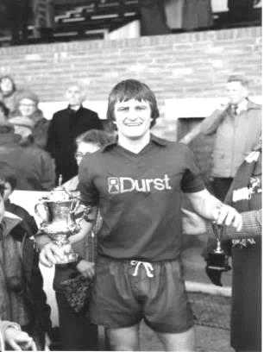
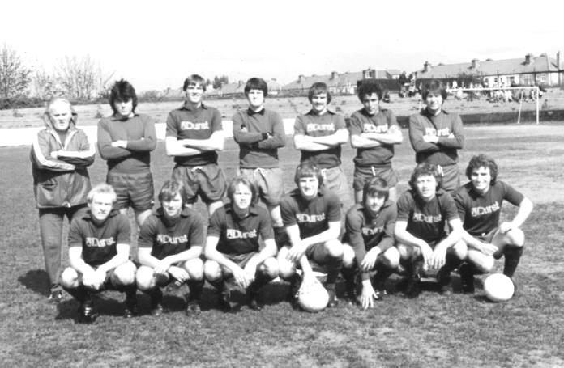
Second Round
Knaphill | 4-3 | Ashford Town (Mx)
Chipstead | 4-1 | Chessington & Hook United
Colliers Wood United | 1-3 | Whyteleafe
Corinthian Casuals | 1-1 | Egham Town
Corinthian Casuals won 4-2 on penalties
Croydon | 3-3 | Farnham Town
Farnham Town won 3-2 on penalties
Godalming Town | 1-0 | Guildford City
Horley Town | 2-2 | Badshot Lea
Badshot Lea won 4-3 on penalties
Leatherhead | 3-0 | Carshalton Athletic
Merstham | 3-0 | South Park
Met Police | 3-2 | Dorking Wanderers
Molesey | 2-1 | Raynes Park Vale
Redhill | 0-3 | Tooting & Mitcham United
Sutton United | 3-0 | Walton & Hersham
Walton Casuals | 1-1 | Kingstonian
Kingstonian won 9-8 on penalties
Westfield | 2-0 | Chertsey Town
Woking | 10-0 | Sutton Common Rovers
Third Round
Godalming Town | 19/1 | Tooting & Mitcham United
Whyteleafe | 6-0 | Farnham Town
Kingstonian | 0-1 | Leatherhead
Played at Leatherhead F.C.
Badshot Lea | 19/1 | Merstham
Westfield | 19/1 | Woking
Met Police | 0-1 | Molesey
Knaphill | 19/1 | Chipstead
Corinthian Casuals | 1-3 | Sutton United

CCL Premier Division Club Directory
A.F.C. HAYES Telephone: 0208-845-0110 - Ground: Farm Park, Kingshill Avenue, Hayes, Middx. UB4 8DD - Colours: Blue and White Stripes/Blue/Blue

ASHFORD TOWN (Mx) Telephone: 01784-245908 - Ground: The Robert Parker Stadium, Short Lane, Stanwell, Middx. TW19 7BH - Colours: Tangerine & White Stripes/Black/Tangerine

BADSHOT LEA Telephone: 01252-320385 - Ground: Ash United FC, Shawfield Stadium, Youngs Drive, Shawfields Road, Ash, Hampshire. GU12 6RE - Colours: Claret/White/Claret

BEDFONT SPORTS Telephone: 0208-831-9067 - Ground: Bedfont Sports Club, Hatton Road, Bedfont, Middx TW14 8JA - Colours: Red & Black Hoops/Black/Red & Black Hoops

CAMBERLEY TOWN Telephone: 01276-65392 - Ground: Krooner Park, Wilton Road, Camberley, Surrey. GU15 2QW - Colours: Red & White Stripes/Blue/Red

CHERTSEY TOWN Telephone: 01932-561774 - Ground: Alwyns Lane, Chertsey, Surrey. KT16 9DW - Colours: Royal Blue & White Stripes/Royal Blue/Royal Blue

CHESSINGTON & HOOK UNITED Telephone: 01372-602263 - Ground: Chalky Lane, Chessington, Surrey. KT9 2NF - Colours: Blue/Blue/Blue

COLLIERS WOOD UNITED Telephone: 0208-942 8062 - Ground: Wibbandune Sports Ground, Robin Hood Way, Wimbledon. SW20 0AA - Colours: Blue & Black Stripes/Black/Black

COVE Telephone: 01252-543615 - Ground: Oak Farm Fields, 7 Squirrel Lane, Cove, Farnborough, Hampshire. GU14 8PB - Colours: Yellow/Black/Yellow

EPSOM & EWELL Telephone: 01737-553250 - Ground: Chipstead FC, High Road, Chipstead, Surrey. CR5 3SF - Colours: Royal Blue & White Hoops/Royal Blue/Royal Blue & White Hoops

FARNHAM TOWN Telephone: 01252-715305 Ground: Memorial Ground, Babbs Mead, West Street, Farnham, Surrey. GU9 7DY Colours: - Claret & Sky Blue /White/ Claret & Sky Blue

GUILDFORD CITY Telephone: 01483-443322 - Ground: The Spectrum, Parkway, Guildford, Surrey. GU1 1UP - Colours: Red & White Stripes/Black/Black

HANWORTH VILLA Telephone: 0208-831-9391 - Ground: Rectory Meadows, Park Road, off Hounslow Road, Hanworth, Middlesex. TW13 6PN - Colours: Red & White Stripes/Black/Black

HARTLEY WINTNEY Telephone: 01252-843586 - Ground: Memorial Playing Fields, Green Lane, Hartley Wintney, Hants RG27 8DL - Colours: Orange & Black/ Orange /Orange

HORLEY TOWN Telephone: 01293-822000 - Ground: The New Defence, Anderson Way, Court Lodge Road, Horley, Surrey. RH6 8SP - Colours: Claret & Sky Blue/Claret/Claret

KNAPHILL Telephone: 01483-475150 - Ground: Brookwood Country Park, Redding Way, Lower Guildford Road, Knaphill, Surrey. GU21 2AY - Colours: Red/Black/Red

SUTTON COMMON ROVERS Telephone: 01932-866386 - Ground: Sutton United FC, Gander Green Lane, Sutton, Surrey SM1 2EY - Colours: Yellow/Black/Black

RAYNES PARK VALE Telephone: 020-8540-8843 - Ground: Prince Georges Playing Field, Grand Drive, Raynes Park, London. SW20 9NB - Colours: Blue/Blue/Red

REDHILL Telephone: 01737-762129 - Ground: Kiln Brow, Three Arch Road, Redhill, Surrey RH1 5AG - Colours: Red and White Stripes/Black/Red

SPELTHORNE SPORTS Telephone: 01932-961055 - Ground: Spelthorne Sports Club, 296 Staines Road, Ashford Common, Ashford, Middx. TW15 1RY - Colours: Light & Dark Blue/Dark Blue/Light Blue

WESTFIELD Telephone: 01483-771106 - Ground: Woking Park, Kingfield Road, Woking, Surrey. GU22 9BA - Colours: Yellow/Black/Black

WINDSOR Telephone: 01753-860656 - Ground: Stag Meadow, St Leonards Road, Windsor, Berks SL4 3DR - Colours: Red/Red/Red

Every Opponent A-Z
Over the years we have played many, many different opponents. Exactly how many is a difficult question, as it all depends on your definition. Are Camberley & Yorktown different to Camberley Town, or are Epsom Town different to Epsom F.C. or Epsom & Ewell F.C.?

In my analysis I have classed them as the same team, and will work through them all from A to Z. Some we have played many times, whilst others we have met just once or twice. Enjoy!

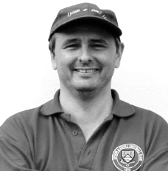
Royal Naval Depot (Chatham): Played 13 - W11 D0 L2 - F48 A18 - PPG - 2.54 - Fantastic

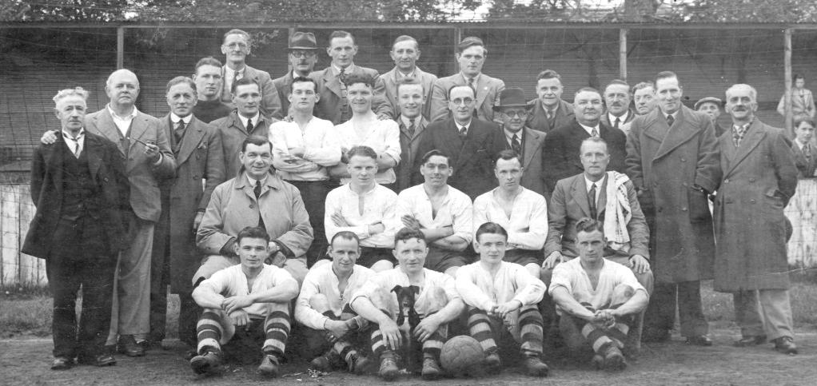
Of all the clubs we have played more than a handful of times I know least about the Royal Naval Depot club from Chatham. What I do know is that they originally had links to the Royal Engineers who appeared in three of the first four F.A. Cup Finals, being runners up to the Wanderers in 1872 in the first final and then winning the competition itself in 1875 against Old Etonians after a replay.

So clearly Chatham had a very strong heritage and the team were good enough to play in the London League Premier Division from the 1936/37 season, without any requirement to work their way through the lower divisions. However, once there, and despite the inclusion of former professional Bernard Radford, they found the challenge too much, with a high water mark of ninth over the six seasons that they met us.

Our first meeting came on Saturday 20th February 1937 at West Street where we won 5-2 with five different players getting on the score sheet and results continued in that vein with the return in April at Chatham finishing 4-1 in our favour. In 1937/38 we raced to a 6-0 half time lead, eventually winning 10-1 at West Street before edging the away game by three goals to two in the January of 1938.

Two further wins followed in the final pre-war season; 4-1 away and 4-0 at home on the final day of that season and the picture below taken that day was therefore our final one before the War.
Epsom FC: Fourth from the left in the main standing row was keeper David Wesley.
The other players were: Back Row: unknown, Bryn Evans
Middle Row: Charles Pettett (Chairman), unknown, Tommy Rochester, A.F.Curtis, Sid Bristow (Trainer)
Front Row: George Baker, Jimmy Jones, Bobby Gill, Geoff Collins, Billy Heal.
The unknown players are: W.H.Calvert and J.H.Stubbs
Of the non-players in the main standing row, we have Harry Cottee (groundsman), Fred Talbot-Butler
(former v-c), David W.G .Jones (Press Sec) and fifth in line is Dick Wilson, a regular player

We rejoined the London League in 1945/46 but the Depot waited until the following season and despite being a very average team ourselves at that point, we resumed normal service defeating them 4-0 on 7th December 1946, although they had their revenge in the final match of the season by five clear goals. We had a full side out so had no excuse. It’s possible that they were able to call on stronger players that day as the match was played on 31st May 1947 following a devastating winter, the like of which has only been seen once since, in 1962/63. This unsurprisingly remains the latest date we have ever played on in a season!

After playing them last that year, we faced them at home in the opening day of the next season in the London League Cup, where despite leading at the half, we lost 3-2. It is bizarre that in 13 matches they only beat us twice, yet they were consecutive matches! (see programme left)
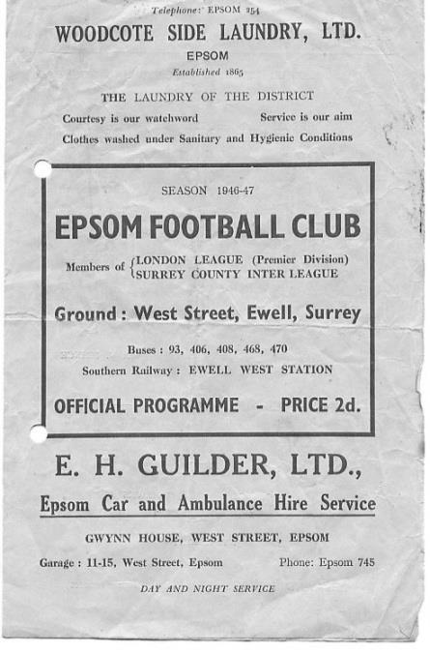
Our two league meetings of 1947/48 were both held in 1948 and a Bill Cutter hat trick secured a 3-0 win over there while two goals from Ken Minter and another from Les Gilbert gave us a 3-1 win at West Street.

Our final two matches took place two weeks apart, in March 1949 with our boys winning 2-1 in Chatham before signing off with a 4-1 win at West Street. By then we probably knew that this was likely to be our last meeting as we had already applied for the Corinthian League and that was how it turned out.

It is not clear how long they remained in the London League but I have traced that they were in the Kent Amateur League (not to be confused with the Kent League) for two seasons from 1954 to 56 but have found nothing else from that point. I still do not even know exactly where in Chatham they played, so if anyone knows, please tell me!

Royal Marines: Played 1 - W1 D0 L0 - F3 A2 - PPG - 3.00 - Perfect

This was another of these post war friendly challenge matches at West Street and we hosted them on Saturday 9th February 1946, winning 3-2 although this probably wouldn’t have been the case had they not allowed us the luxury of a half time substitute, due to injury, as Sargeant D.F. Bayly, as he was still known, came on for the second half.

Royal Ordnance Factories: Played 1 - W1 D0 L0 - F6 A2 - PPG - 3.00 - Perfect

We hosted the Royal Ordnance Factories, a Woolwich based organisation in an Amateur Cup tie on Saturday 29th September 1962. They had been drawn at home but waived their right to ground choice so that a gate could be taken. Not that it was much of a gate as we were quite a poor team back then, despite the Management of former player Fred Chitty, who had success in his first spell in charge a few years previously.

We still had far too much for them and won easily 6-2 with a hat trick for Derek Prowse before Leatherhead knocked us out in the next round.

Player Sponsorship
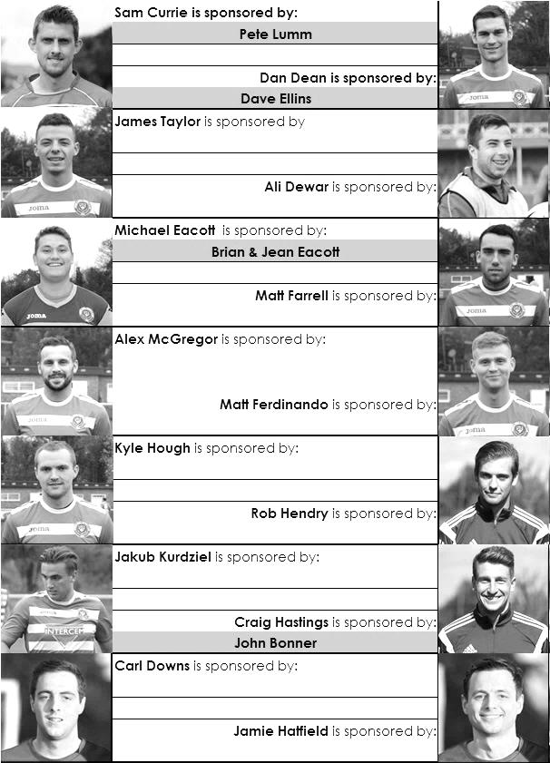

Here is the current list for the 2015/16 season showing all of our players and Management that are currently available for sponsorship this season.

Sponsorship costs just £40 and it is easy to do. Just select a player who has not been previously sponsored and let a Committee Member know that you would like to sponsor them. Beware though. Until we have received the money it is possible for someone to jump in front of you, so don’t delay, sponsor today!

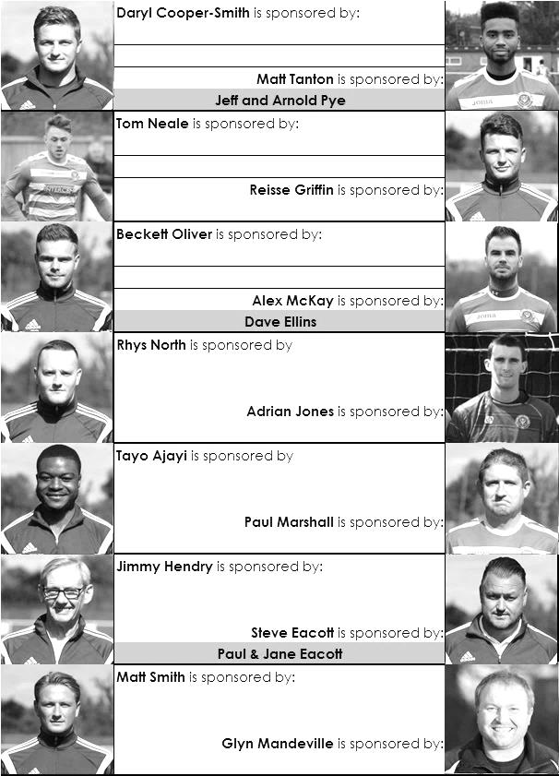

F.A. Vase – Fourth Round
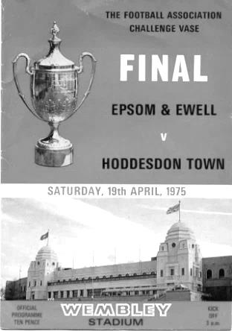
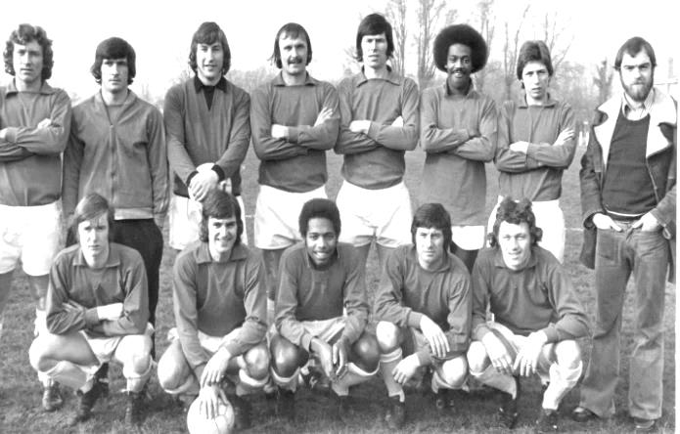

Cleethorpes Town | 2-1 | Alvechurch
Northern Counties East – 5th |  | Midland – 2nd
Hereford | 16/1 | Leicester Nirvana
Midland – 1st |  | United Counties – 1st
South Shields / Morpeth Town | 16/1 | North Shields
 |  | Northern – 10th
Coleshill Town | 16/1 | Dunston UTS
Midland – 13th |  | Northern – 4th
AFC Wulfrunians | 2-3 | Nuneaton Griff
Midland – 6th |  | STEP 6 - Midland Division 1 – 5th
Sunderland RCA | 16/1 | Sleaford Town
Northern – 9th |  | United Counties – 10th
Newton Aycliffe | 16/1 | Marske United
Northern – 6th |  | Northern – 7th
Bowers & Pitsea | 16/1 | Sutton Common Rovers
Essex Senior – 6th |  | Combined Counties – 10th
Kidlington | 16/1 | Knaphill
Hellenic – 3rd |  | Combined Counties – 14th
Newport IOW | 16/1 | Ashford United
Wessex – 9th |  | Southern Counties East – 3rd
Moneyfields | 16/1 | Bristol Manor Farm
Wessex League – 16th |  | Western League – 1st
FC Romania | 1-2 | Camberley Town
Essex Senior – 3rd |  | Combined Counties – 4th
AFC Dunstable | 0-3 | Salisbury
South Midlands – 2nd |  | Wessex – 1st
Berkhamsted | 4-2 | Hullbridge Sports
South Midlands – 7th |  | Essex Senior – 9th
Hartley Wintney | 16/1 | Bradford Town
Combined Counties – 2nd |  | Western League – 8th
Bodmin Town | 16/1 | Ipswich Wanderers
STEP 6 – South Western – 1st |  | Eastern Counties – 11th

Player Profile – Number 12 – Michael Eacott
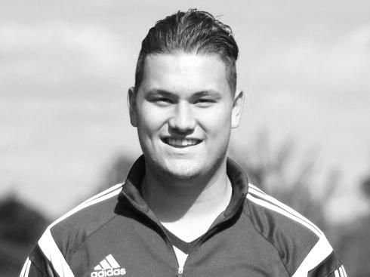
Our latest player profile is from the big man between the posts, Michael Eacott.

Age: 20

Position: Goal keeper

Club supported: Chelsea

Favourite Food: Chicken

Favourite Film: Goal 1 / Jimmy Grimble

Messi or Ronaldo: Ronaldo

Favourite Drink: Strawberry & Lime Rekorderlig

Favourite Ground played at: Griffin Park, Brentford FC

Best Moment for Epsom & Ewell: My first clean sheet for the club. 3-0 at Spelthorne Sports – 27th September 2014

Describe the Gaffa in three words: Funny – Ginger – Banter

Previous Clubs: Chipstead, Erith Town, Colliers Wood, Brentford (academy)

Michael’s Playing Stats: First Team Debut : 02/08/2014

Appearances: 70 - Sub: 0 - Total: 70 - Goals: 0

Club Fund Raising Evening – 23rd January
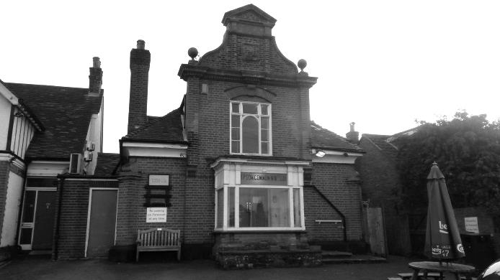
Following our trip to Windsor on 23rd January we will be holding a Categories Quiz Evening with local entertainer Martin Firmo, who is a former player at this level and will provide entertainment of the highest quality. The format is slightly different from a traditional quiz and so there is a bit of novelty value too!

The evening will be at a convenient local venue as it is to be held at the Epsom Common Working Mens Club (pictured), which is at the Stamford Green end of Epsom and entry is just £10. Please consider putting a team together and coming along, but if on your own, we can find you a team! The beer is cheap, it’s local and you get to meet the players too; it’s all good!

The fun will not start until 7.30 so you have plenty of time to watch the game and get back in time for what promises to be an interesting evening. Please speak to Steve Dyke to purchase tickets which are available now.

Match and Ball Sponsorships – 2015/16
Opponent | Date | Match Sponsor | Match Ball Sponsor
Hoddesdon Town | 18/07/15 | Geoff Dyke
Windsor | 08/08/15 | Club President - Stella Lamont
Erith & Belvedere (FAC) | 16/08/15 | Committee Member - Mike Lovett
Raynes Park Vale | 31/08/15 | EEFC Management Committee
Colliers Wood United | 08/09/15 | Bookham Building Shop – www.buildingshop.co.uk
AFC Hayes | 19/09/15 | John Bonner
Farnham Town | 26/09/15 | Ezara and Inaya Beddoe – our youngest supporters!
Chertsey Town | 17/10/15 | Club Media Officer – Richard Lambert
Dorking Wanderers (SSC) | 20/10/15 | Tony Ferdinando
Chessington & Hook United | 07/11/15 | Paul Merritt
Hanworth Villa | 21/11/15 | Maggie Beddoe
Guildford City | 05/12/15 | Pete Lumm
Sutton Common Rovers | 19/12/15 | Marvin Hough
Ashford Town (Mx) (LC) | 12/01/16
Spelthorne Sports | 16/01/16
Hartley Wintney | 30/01/16 | ---- Provisional fixture ----
Redhill | 02/02/16 | David Lawton
Bedfont Sports | 13/02/16
Horley Town | 27/02/16
Knaphill | 12/03/16
Cove | 15/03/16
Westfield | 26/03/16
Badshot Lea | 09/04/16
Camberley Town | 16/04/16
Ashford Town (Mx) | 30/04/16 | Brian Eacott
For League, League Cup and Surrey Senior Cup Matches:
Match sponsorship - £40.00 Match ball sponsorship - £25.00. Combined £55.00.
For F.A. Cup and F.A. Vase matches:
Match sponsorship - £50.00 Match ball sponsorship - £30.00. Combined £65.00.

Sponsorship includes: ( x2 for match, x3 for match and ball )

Admission, programmes, hospitality, advertising and mascot for the day ( if required ).
If you are interested, just speak to a Committee Member, or drop me an email at: richard.c.lambert@gmail.com


We also thank our Kit Sponsors INTERCEM

Salts Super Six Predictor
The Salts Super Six Predictor Competition is live again and the tickets are on sale at the ground. We have five from the Premier League and one from the Championship today.

The competition is easy to play! To win, you simply need to predict the results of the six matches correctly from the three options, fill in the form and make sure it is back with our sellers before the deadline on the ticket.

If you are a club regular, you just need to place your name on the sheet, although if you aren’t, then we’ll need a contact number from you too. We will announce any winners on the website within three working days, so don’t worry we won’t miss you!

The jackpot is now at £167 and who knows how high it could go this time!

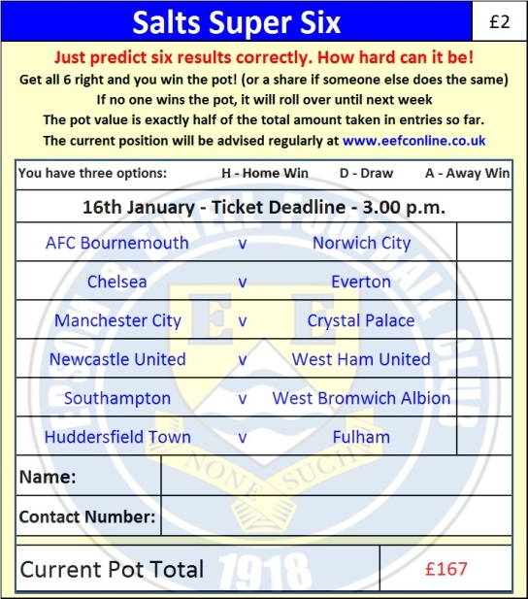
Please note that if there is more than one winner, the prize pot would be shared between the winners. All you need to do now is have a go, as many times as you like!

Good luck!

Combined Counties League – Premier Division
Saturday, 16th January 2016 - Kick-off 3.00 p.m.
Epsom and Ewell  (Royal Blue & White hoops) | V |  | Spelthorne Sports  (All White)
Squad | NUMBERS |  | Squad
Michael Eacott |  |  | Dane Buss
Sam Currie |  |  | Billy Roach
Alex McKay |  |  | Junior Wright
Craig Hastings |  |  | Qaseem Soronwa
Dan Dean |  |  | Frankie Law
Carl Downs |  |  | Callum Mackay
Reisse Griffin |  |  | Simo Mbonkwi
© Matt Farrell |  |  | Jake Hicks
Kyle Hough |  |  | Lee Staples
Tom Neale |  |  | Conor Moody
Matt Ferdinando |  |  | Ashley Quashie
James Taylor |  |  | Jake Flatman
Beckett Oliver |  |  | Joe Goodman
Rob Hendry |  |  | Joe Lynch
Matt Tanton |  |  | Simon Murray
Savvas ‘Agi’ Panayiotou |  |  | Clint Church
Adrian Jones
Rhys North
Alex McGregor
Matt Smith
Jamie Hatfield
Glyn Mandeville | MANAGER |  | Steve Flatman
Matt Smith | ASSISTANT |  | Paul Burgess / Mark Harper
Steve Eacott / Alex McKay / Jimmy Hendry | COACHES / PHYSIO
REFEREE: O.Davies (London)
ASSISTANTS: P.Saunders (Knaphill), K.Parker (Roehampton)

OUR NEXT VISITORS TO HIGH ROAD ARE (PROVISIONALLY):
Hartley Wintney

Saturday 30th January 2016 - Kick-off 3.00 p.m.
Combined Counties League – Premier Division

